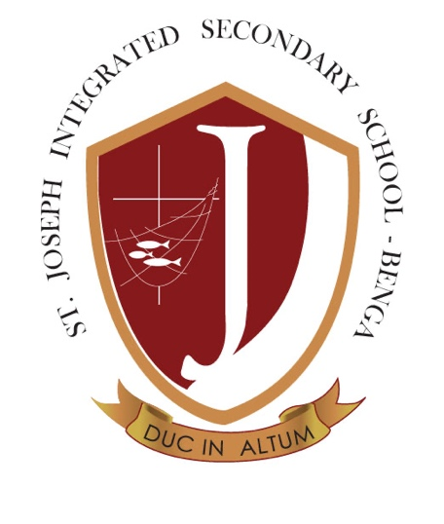

ST. JOSEPH INTEGRATED SECONDARY SCHOOL

CLASSROOM POLICY
Approved by: Board of Governors, St. Joseph Integrated Secondary School, Benga

PREAMBLE: ALIGNING WITH OUR FIVE FOUNDATIONAL PILLARS
This classroom policy is a comprehensive embodiment of our school's five foundational pillars, reflecting our vision to transform society through holistic education. As guided by our motto "Duc in Altum" (Cast into the Deep), we challenge ourselves to go beyond conventional teaching, creating a learning environment that nurtures the whole person.
Our Vision: Transformation of society and humanity by producing citizens who are grounded in the truth and rooted in Catholic values with a spirit of service and respect for others.
Our Mission: To provide holistic (integrated) education that promotes human dignity and development infused with the gospel truth and Catholic values in an environment of freedom and responsibilities for the service of community and humanity at large.

1. PILLAR 1: FAITH FORMATION AND MORAL DEVELOPMENT IN THE CLASSROOM

1.1 Spiritual Integration
- Every classroom session begins and ends with prayer
- Catholic values are explicitly integrated into all subject matter
- Ethical decision-making is a core component of classroom discourse
- Respect for diverse religious backgrounds while maintaining our Catholic identity

1.2 Moral Development
- Classroom interactions model Christ-centred principles of respect and dignity
- Discussions emphasize personal integrity, compassion, and moral reasoning
- Teaching approaches that develop a strong sense of right and wrong

2. PILLAR 2: ACADEMIC EXCELLENCE WITH LOCAL RELEVANCE

2.1 Curriculum Implementation
- Rigorous academic standards exceeding national requirements
- Locally relevant content addressing Malawian context and challenges
- Integration of critical thinking and problem-solving skills
- Balanced approach between theoretical knowledge and practical applications

2.2 Innovative Learning Approaches
- Curriculum that prepares students for tertiary education and entrepreneurship
- Technology integration despite infrastructure limitations
- Practical learning experiences that connect academic concepts to real-world scenarios

3. PILLAR 3: HOLISTIC HUMAN DEVELOPMENT

3.1 Comprehensive Student Support
- Classroom practices that nurture intellectual, physical, emotional, and spiritual dimensions
- Personalized learning approaches addressing individual student needs
- Leadership opportunities embedded within classroom activities
- Mental and physical health considerations in learning design

3.2 Inclusive Education
- Accommodations for students with diverse abilities and backgrounds
- Teaching methodologies that respect individual learning styles
- Promotion of resilience, self-knowledge, and personal growth

4. PILLAR 4: COMMUNITY SERVICE AND SOCIAL JUSTICE

4.1 Service-Oriented Learning
- Classroom activities that connect learning to community needs
- Projects that analyse and address social structures and development challenges
- Opportunities for student-led initiatives promoting positive social change

4.2 Social Awareness
- Curriculum that integrates Catholic social teaching principles
- Critical analysis of local and global social justice issues
- Development of empathy and commitment to community service

5. PILLAR 5: SUSTAINABLE RESOURCE STEWARDSHIP

5.1 Environmental Education
- Integration of ecological practices and environmental awareness across subjects
- Classroom projects focusing on sustainable resource management
- Learning experiences that promote responsible environmental stewardship

5.2 Practical Resource Management
- Teaching financial literacy and responsible resource allocation
- Practical skills development in sustainable practices
- Innovative approaches to learning with limited resources

CORE CLASSROOM PRACTICES

Teaching Methodologies
- Learner-centred approaches
- Integration of faith and reason
- Balanced between academic rigor and practical skill development
- Emphasis on independent and critical thinking

Assessment Strategies
- Holistic evaluation considering academic, spiritual, and personal growth
- Multiple assessment methods reflecting our integrated educational approach
- Feedback mechanisms that support continuous personal development

Technology and Learning
- Purposeful technology integration
- Digital literacy with an emphasis on responsible use
- Technology as a tool for deeper learning and community engagement

IMPLEMENTATION AND COMMITMENT
This policy is more than a set of rules—it is a living embodiment of our commitment to transformative education. By aligning every classroom practice with our five foundational pillars, we ensure that each student receives an education that:
- Grounds them in Catholic values
- Provides academic excellence
- Nurtures their entire being
- Prepares them for community service
- Develops responsible stewardship
"Duc in Altum" - Cast into the Deep Our classroom is not just a place of learning, but a transformative space where students are challenged to dive deep into knowledge, faith, and personal growth.
Document to be reviewed: May 2027
St. Joseph Integrated Secondary School: Transforming lives through education that integrates academic excellence, practical skills, and Catholic values through our five foundational pillars.

